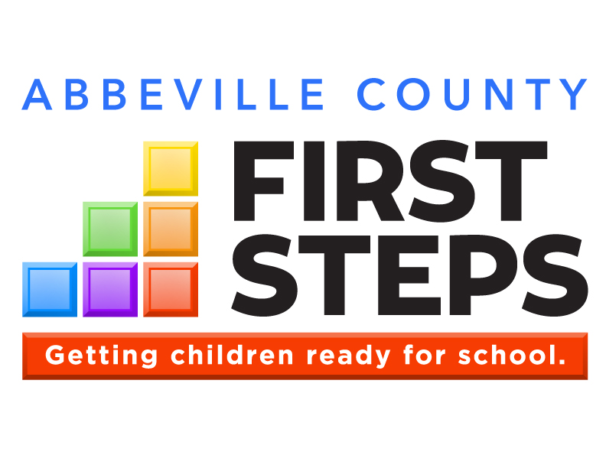

OUR VISION:

Every South Carolina child will arrive at kindergarten
ready to succeed.
After you import your new logo for the first time (Insert Picture), right-click on the image, select “Size and Position”, choose the “Text Wrapping” tab and select “In Front of Text” so the logo will cover anything it overlaps. Copy/paste this image to your other pages. If you right-click on the image and select “Change Picture”, all formatting will be correct. Delete this text box.

Annual Report

2016-17
Parents as Teachers
Imagination Library
Countdown to Kindergarten
Child Care Quality Enhancement
Child Care Training
Child Care Scholarships
**Note: Change Photos throughout document.
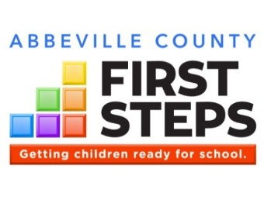
To create a map image with your county highlighted, double-click on your county (not on the county name) and then select “Shape Fill” from the menu at the top. Then copy and paste the entire map to the annual report.
Delete this text box.

XYZ COUNTY
By The Numbers
Indicator | SC | XYZ County
Children Under Five | 293,134 | 2,033
Children In Poverty | 24.4% | 32.9%
3rd Graders Below Standard in Reading | 22.2% | 28.6%
Births to Mothers With Less Than a High School Diploma | 15.0% | 15.7%
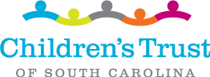

- Since inception, XYZ County First Steps has leveraged $1,249, 254 from sources outside state government. That’s $.47 for every dollar received.

- 759 hours of support and guidance were provided to 31 families in our Parents As Teachers Program.

- Childcare professionals received 30 hours of technical assistance for early care best practices.

- Improved parenting practices through 14 Group Connections Parent Workshops.

- Total Children Served in FY17: 31

XYZ County First Steps
123 Main Street
City, SC ZIP
Phone: (803) 123-4567
Fax: (803) 123-4567
Board Chair
NAME
Email address
www.yourwebsite.org

County Programs
Parents as Teachers
Child Care Training

The data for this chart can be found on the Kids Count Data Center web site for SC (2015 data): http://datacenter.kidscount.org/data#SC/2/0/char/0
For Grade 3 Reading, the 2016 SC Ready scores are available at:
http://ed.sc.gov/data/test-scores/state-assessments/sc-ready/2016/
The state statistics in this chart have already been updated.
Use the link and then find your county partnership for your data. Delete this text box.
KIDS COUNT data provided by
State Programs
Early Head Start
First Steps 4k

School
Transition
Early
Education
Quality
Child Care
Early
Intervention
Family
Strengthening

Heathy
Start

XYZ County First Steps
Name
Executive Director

Here is where you describe local examples using collaborations and partnerships to expand services for children and families, as well as dollars leveraged. Here is where you describe local examples using collaborations and partnerships to expand services for children and families, as well as dollars leveraged.
Here is where you describe local examples using collaborations and partnerships to expand services for children and families, as well as dollars leveraged. Here is where you describe local examples using collaborations and partnerships to expand services for children and families, as well as dollars leveraged.
Here is where you describe local examples using collaborations and partnerships to expand services for children and families, as well as dollars leveraged. Here is where you describe local examples using collaborations and partnerships to expand services for children and families, as well as dollars leveraged. Here is where you describe local examples using collaborations and partnerships to expand services for children and families, as well as dollars leveraged.

www.yourwebsite.org
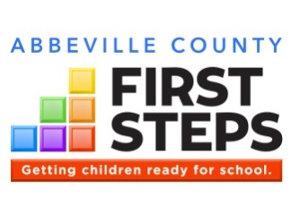
Each of the six color blocks of the First Steps logo represents a core area of service, outlining our comprehensive strategy to prepare children for long-term school success.

With measurable outcomes across each of its six school readiness strategy areas, First Steps is getting results.

What We Do

Healthy Start
We begin with a focus on providing a healthy start to life. This includes prenatal and post-partum services for both mother and baby. In 2007, First Steps collaborated with key philanthropic and agency partners to bring Nurse-Family Partnership to SC having a significant impact on reducing premature births and Medicaid costs.

Family Strengthening
Our home visitation strategies, such as Parents as
Teachers, Parent-Child Home and Early Steps to
School Success, are helping parents understand their responsibilities to care for and be positive models for their children. As a result of First Steps’ intervention and parenting support, 66% of clients initially assessed at “low” levels of parenting have achieved moderate or high levels of parenting skill.

Early Intervention
Children’s school readiness depends on their healthy growth and development. First Steps helps identify potential delays early through developmental screenings and referring children to BabyNet and other early intervention resources.
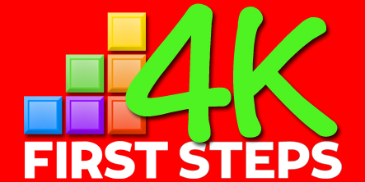
Interested parents can contact any participating 4K providers to complete an application. To view a list of participating First Steps 4K providers, visit:
http://scfirststeps.org/4k
Quality Childcare
Quality childcare starts with quality childcare providers. Our quality enhancement and training strategies lead to improved teacher-student interaction, which research shows has a significant impact on a child’s development and success in school.

Early Education
Private-public partnerships through First Steps 4K have led to significant cost efficiencies in the delivery of publicly funded 4K. One recent analysis suggests First Steps is achieving comparable results, without the need for costly capital construction, for 80 cents on the dollar. Early Head Start expands quality early learning and family support to infants and toddlers.

School Transition
Each of the corresponding blocks of services leads ultimately to the goal of transitioning children successfully to school. Programs like Countdown to Kindergarten are ultimately preparing children for school success.

Based on the needs of our community, XYZ County First focuses its investments in…. NAME THE CATEGORIES ABOVE THAT YOUR PARTNERSHIP CURRENTLY INVESTS IN.

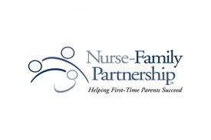
Helping vulnerable first-time mothers empowers them to achieve a better life
for themselves and their children.

Nurse-Family Partnership

Program Description
The risk factor box underneath is a Table. To add or delete lines, you must Insert or Delete Rows by right-clicking on the appropriate line. This applies to all pages that include a risk factor box.
Use data from the Risk Factor Report to find the most compelling statistics for your program.
Delete this text box.
This year, our NFP program (contact jkilburn@scfirststeps.org for assistance, if needed):
- IF AVAILABLE, INCLUDE STATISTICS ON CLIENT SATISFACTION (satisfaction survey, training evals, etc.)
- Achieved ??? results for healthy pregnancy, healthy birth outcomes
- Achieved ???? results for improved parent behaviors, like quitting smoking, parenting skills, etc.
- Graduated ??? families (if applicable)

Here’s a great quote from a client!
Client name

Nurse-Family Partnership (NFP) helps transform the lives of vulnerable first-time mothers and their babies. Through ongoing home visits from registered nurses, low-income, first-time moms receive the care and support they need to have a healthy pregnancy, provide responsible and competent care for their children, and become more economically self-sufficient. From pregnancy until the child turns two years old, Nurse-Family Partnership Nurse Home Visitors form a much-needed, trusting relationship with the first-time moms, instilling confidence and empowering them to achieve a better life for their children – and themselves.
In XYZ County, Nurse-Family Partnership is implemented through XYZ Organization.

XYZ First Steps serves families in greatest need. Among our NFP families:
XX% | … live in poverty
XX% | … graduate from high school
XX% | … had developmental delays

NFP by the Numbers, 2016-17
Children Served | Matrix C34
Number of Home Visits | Matrix F34

XYZ County First Steps
Address, City, ZIP
Phone
Email Web Address

Thank you to our partners!
U.S. Department of Education
XYZ County School District Family Literacy
ABC Child Care
Fairview Mental Health Services

Early Identification and Referral
Identifying and referring children with possible developmental delays can help assure school readiness.

Program Description
Here’s a great quote from a client!
Client name
Also include any measures of client satisfaction HERE or in the results below

First Steps’ Early Identification and Referral (EI&R) programs serve families with young children with suspected delays in development and coordinates public awareness for BabyNet services, acting as a local portal to connect families to community-based services they may need or desire to ensure the school readiness of their children
EI&R services include:
- Screenings (developmental, vision, hearing) for children ages birth to 5 years with suspected delays in development
- Referrals, based up the screening results, to appropriate community resources. This could include the local BabyNet System Point of Entry Office, the local school district, and/or support services such as speech therapy, physical therapy, and programs in libraries and other community resources.
- Parent information including strategies to monitor growth and development.
Our EI&R program:
- Provides early detection of developmental delays and health issues
- Promotes services and activities that promote child development
- Increases children’s school readiness and school success

XYZ First Steps serves families in greatest need. Among our EI&R families:
X% | … live in poverty
% | … didn’t graduate high school
25% | … were teen parents

The risk factor box underneath is a Table. To add or delete lines, you must Insert or Delete Rows by right-clicking on the appropriate line. This applies to all pages that include a risk factor box.
Use data from the Risk Factor Report to find the most compelling statistics for your program.
Delete this text box.
Use text boxes to caption your photos as often as possible. Many readers will focus on these more than the report text.

EI&R by the Numbers 2016-17
Children Served | Matrix C76
Materials Distributed | Matrix D76
Children Referred to BabyNet, Local School, or Other Services | FSDC EI&R outputs: #13 + #16

This year, our Early Identification and Referral program:
- Screened xxxx number of children using Ages and Stages Questionnaire
- Referred xxxxx number of families to community resources after screening indicated need

XYZ County First Steps
Address, City, ZIP
Phone
Email Web Address

Thank you to our partners!
XYZ County School District Family Literacy
ABC Child Care
Fairview Mental Health Services

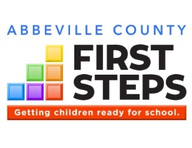
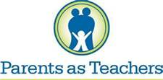

Here’s a great quote from a client!
Client name
Also include any measures of client satisfaction HERE or in the results below

Parents as Teachers

Program Description
Parents play a critical role in their child’s development.
The risk factor box underneath is a Table. To add or delete lines, you must Insert or Delete Rows by right-clicking on the appropriate line. This applies to all pages that include a risk factor box.
Use data from the Risk Factor Report to find the most compelling statistics for your program.
Delete this text box.
Parents as Teachers (PAT) is an evidence-based home visiting program designed to build strong communities, thriving families and children who are healthy, safe and ready to succeed. PAT services include:
- Personal Visits at least twice monthly
- Monthly Group Connections with other PAT families
- Screenings and Assessments to identify developmental concerns
- Connections to Outside Resources that families may need to succeed
XYZ First Steps serves families in greatest need. Among our PAT families:
100% | … live in poverty
50% | … didn’t graduate from high school
25% | … were teen parents

PAT by the Numbers 2016-17
Families Served | Matrix D26
Children Served | Matrix C26
Total Home Visits | Matrix F26
Hours Spent Serving Families | Matrix: G26+I26
Average gain, Keys to Interactive Parenting Scale (pre-to-post): | KIPS/ACIRI Detail Report | KIPS/ACIRI Detail Report

Use text boxes to caption your photos as often as possible. Many readers will focus on these more than the report text.

This year, our Parents as Teachers program:
- Averaged XX home visits per family (Parenting Home Visit Intensity Report, Avg. Number of Visits)
- Identified and addressed XX potential developmental delays (ASQ Report), and made ## connections for families to services such as ??????? (Connections Detail Report)
- Improved parenting practices write something about your pre-to-post changes KIPS, LSP, or other evidence
- Improved literacy skills write something about pre-to-post changes in ACIRI, activities from PAT lessons, # of books distributed (Matrix C18, Cases Visit Summary & PTS Report), or other evidence

XYZ County School District Family Literacy
ABC Child Care
Fairview Mental Health Services

Thank you to our partners!

XYZ County First Steps
Address, City, ZIP
Phone
Email Web Address
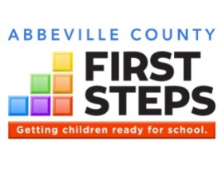

Family Literacy
Parents are their child’s first and best teachers.

Program Description
Also include any measures of client satisfaction HERE or in the results below
The risk factor box underneath is a Table. To add or delete lines, you must Insert or Delete Rows by right-clicking on the appropriate line. This applies to all pages that include a risk factor box.
Use data from the Risk Factor Report and program records to find the most compelling statistics for your program.
Delete this text box.
Family literacy programs offer an integrated and family-friendly approach, helping both parents and children to improve their literacy skills. Family literacy services integrate all of the following:
- Adult Education
- Child Education
- Parent Education
- Interactive Parent/Child Activities
Our family literacy program:
- Helps parents of young children increase their education levels
- Provides English language instruction for parents (delete if not the case)
- Teaches parents how to support their child’s literacy and overall development
- Provides quality early learning experiences for children 0-5 while their parents attend adult education
XYZ First Steps serves families in greatest need. Among our family literacy program families:
X% | … live in poverty
X% | … didn’t graduate high school
X% | … enrolled in our program with less than an eighth grade education

This year, our Family Literacy program:
- Increased the education levels of participating parents by an average of ? grade levels in ???? (pre to post TABE scores in reading and/or math)
- Increased the vocabulary skills of participating children by ??? (pre to post PPVT scores)
- Other results such as: participants enrolling in higher education or getting a job; ESL parents achieving gains in their English language skills (pre to post BEST);

Family Literacy by the Numbers 2016-17
Adults Served | Matrix E50
Children Served | Matrix C50
Adult Education Hours Offered | Matrix H50
Early Childhood Education Hours Offered | Matrix J50
Parenting Education Hours Offered | Matrix I50
Number of adults that achieved their HS diploma or GED | FSDC, Case Info screen

Use text boxes to caption your photos as often as possible. Many readers will focus on these more than the report text.

Thank you to our partners!

XYZ County First Steps
Address, City, ZIP
Phone
Email Web Address
U.S. Department of Education
XYZ County School District Family Literacy
ABC Child Care
Fairview Mental Health Services

Imagination Library
Children’s reading scores improve dramatically when parents are involved
in helping them learn to read.

This year, our Imagination Library program:
- Provided one book per month to (Matrix C54) children who were referred from LIST
REFERRAL SOURCES
- Other results such as: results from client surveys; connections with other programs such as
PAT, Head Start, etc.
- Received donations from ?? community members and organizations in support of children’s literacy (if applicable)
- IF AVAILABLE, INCLUDE STATISTICS ON CLIENT SATISFACTION (satisfaction survey, training evals, etc.)

Sponsor a child
today for just $25!

Imagination Library by the Numbers, 2016-17
Children Served | Matrix C54
Books Given to Children 0-5 | Matrix C17

Use text boxes to caption your photos as often as possible. Many readers will focus on these more than the report text.
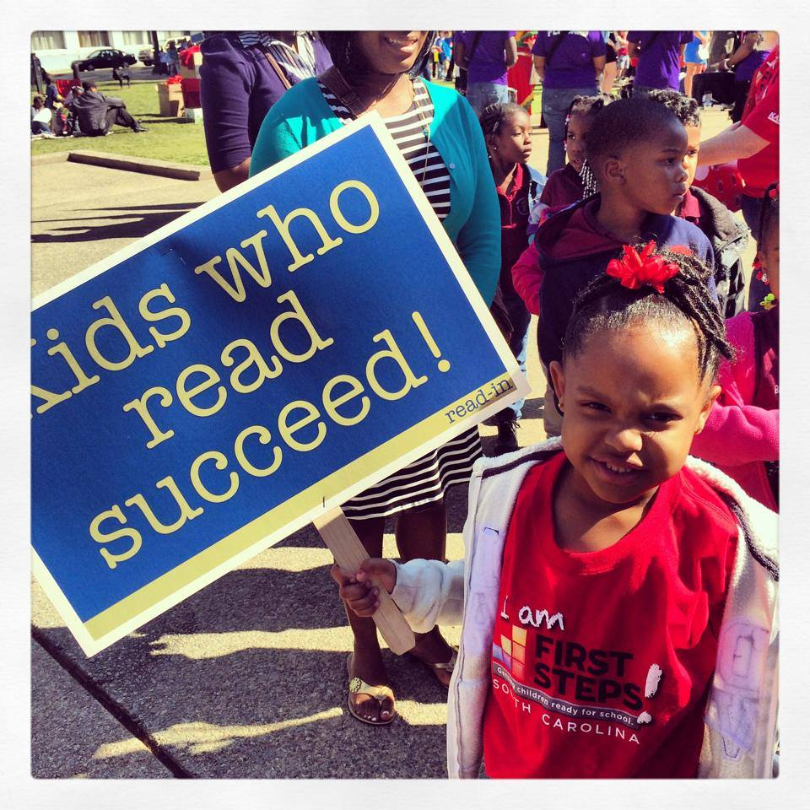

Thank you to our partners!
Dollywood Foundation
XYZ County School District Family Literacy
WalMart Store #1001, XYZ
Dollar General Literacy Foundation

Program Description
According to the Center on the Developing Child at Harvard University, the peak period for brain development related to language is around nine months of age. One of the easiest and most effective ways to build this capacity in young children’s brains is to read to them.
XYZ First Steps is the local sponsor of Dolly Parton Imagination Library, which provides free, age-appropriate books to children age birth to 5 years. Operated by the Dollywood Foundation, Imagination Library is currently in more than 1,600 communities internationally and mails books to about 700,000 children each month.
Children who register with XYZ First Steps receive one book per month by mail through the month of their fifth birthday. Each book is carefully selected by a committee of educational specialists.

XYZ County First Steps
Address, City, ZIP
Phone
Email Web Address
In order to thrive, children need nurturing, responsive relationships and a
supportive learning environment, both within and outside the home.

Child Care Quality Enhancement

QE by the Numbers, 2016-17
Child Care Providers Served | Matrix D62
Number of TA Visits Provided | Matrix E62
Number of Children 0-5 Enrolled in Provider Classrooms | Matrix C62

Program Description
The QE pre/post box underneath is a Table. To add or delete lines, you must Insert or Delete Rows by right-clicking on the appropriate line.
Delete this text box.
This year, our Quality Enhancement program:
- IF AVAILABLE, INCLUDE STATISTICS ON CLIENT SATISFACTION (satisfaction survey, training evals, etc.)
- Improved quality, on average, by X.X based on pre/post Environment Rating Scale assessments. (Child Care Intensity Summary Report, Column “ERS Change, Pre to Post”)
- Provided XX hours of technical assistance to child care providers (Matrix F62)
- Provided $????? in materials grants to participating child care providers (if applicable)
- Funded scholarships for XX children within participating child care providers (if applicable)

Congratulations to our QE participants for 2016-17!
Child Care Provider | Pre/Post Improvement
Name of Provider, toddler room | From 2.6 to 3.5
Name of Provider, infant room | From 3.0 to 3.3
Name of Provider, 2-yr-old room | From 1.9 to 3.2
Name of Provider, 3-yr-old room | From 2.0 to 2.4
Name of Provider, infant room | From 3.2 to 3.6

The quality of care they received by young children is crucial to their healthy development and school readiness. Child care providers strive to provide high quality care, but may lack the resources that are commonly available to publicly-funded early childhood programs, such as educational materials, on-site professional development, and other support.
First Steps’ Child Care Quality Enhancement (QE) is intended to produce measurable improvements in the quality of care provided to young children. Participating child care providers must serve a high percentage of at-risk children, and are selected through a competitive process that requires a strong level of commitment to the QE process.
Program Components
- On-site Technical Assistance (TA) at least twice monthly
- Equipment and materials funding
- Integration with locally available training, provided by First Steps and other partners
- Workforce Development
- Coordination with community partners
- Pre/post assessments of the classroom environment and teacher-child interaction, using nationally-recognized observational tools for infant/toddler and preschool settings (ITERS,ECERS,FCCERS)

XYZ County First Steps
Address, City, ZIP
Phone
Email Web Address

Thank you to our partners!
U.S. Department of Education
XYZ County School District Family Literacy
ABC Child Care
Fairview Mental Health Services

Those who care for young children need high-quality, accessible, and affordable professional development.

Child Care Training

Use text boxes to caption your photos as often as possible. Many readers will focus on these more than the report text.
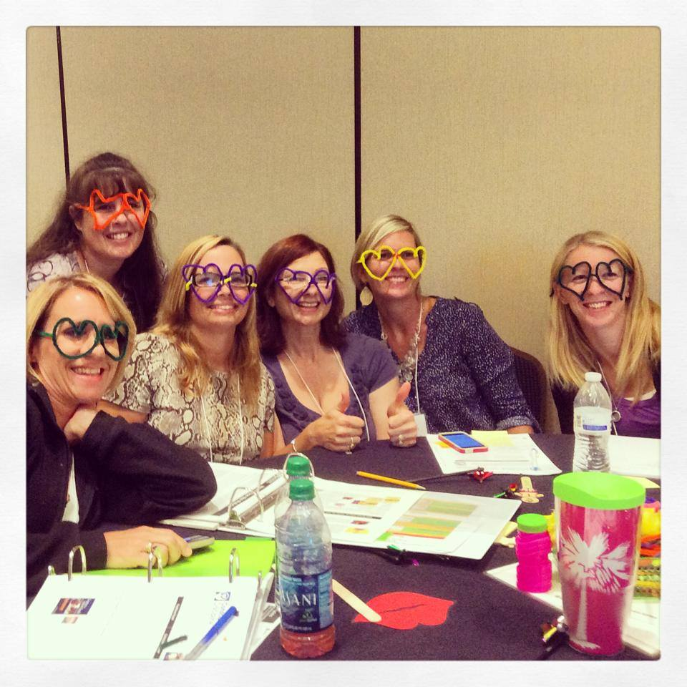
This year, our Training program provided:
- XX early childhood staff with high quality training (Matrix C65)
- XX hours of certified training (Matrix F65) and XX hours of registered training (Matrix G65) for staff to meet annual re-certification requirements
- XX follow-up visits (Matrix H65) with training participants to help put training into practice

Training by the Numbers, 2016-17
Total Training Attendance | Matrix D65
Child Care Teachers and Directors Served | Matrix C65
Number of Training Sessions Offered | Matrix E65

Child Care Training Sponsored by
XYZ First Steps, 2016-17
Topic: Sessions:
SC Infant/Toddler Guidelines Modules 1,2, and 5
Preventing Child Abuse and Neglect:
Parent-Provider Partnerships Modules 1 and 3
Blood-Borne Pathogens One Session
Early Literacy in the Child Care
Classroom Three Sessions

High-quality child care hinges on high-quality professional development that meets the needs of the local child care workforce.
First Steps-sponsored training is certified through the SC Center for Child Care Career Development and includes topics in the areas of nutrition, health and safety, curriculum, child guidance, professional development and program administration. Best practices in training include not only the training itself, but follow-up in the classroom.

Program Description

Thank you to our partners!

XYZ County First Steps
Address, City, ZIP
Phone
Email Web Address
U.S. Department of Education
XYZ County School District Family Literacy
ABC Child Care
Fairview Mental Health Services

Here’s a great quote from a client!
Client name
Also include any measures of client satisfaction HERE or in the results below

Child Care Scholarships
Too many families in XYZ County cannot afford quality care for their children.

Program Description
Here’s a great quote from a client or child care provider!
Client name
Also include any measures of client satisfaction HERE or in the results below

The risk factor box underneath is a Table. To add or delete lines, you must Insert or Delete Rows by right-clicking on the appropriate line. This applies to all pages that include a risk factor box.
Use data from the Risk Factor Report to find the most compelling statistics for your program.
Delete this text box.
Use text boxes to caption your photos as often as possible. Many readers will focus on these more than the report text.

Scholarships by the Numbers, 2016-17
Children Served | Matrix C70
Providers Served | Matrix D70

This year, our Scholarship program:
- Provided XX children (Matrix C70) with scholarship assistance so their parents could work or attend school
- Identified and addressed XX potential developmental delays among scholarship children (ASQ Report)
- Made ## connections for families to services such as ??????? (Connections Detail Report and joint services like PAT)
- Supported XX small businesses (Matrix D70) in XYZ County by subsidizing child care tuition for families who would not otherwise be able to afford quality care
- Provided XX hours (Matrix F70) of training for scholarship parents in topics such as ???????

Access to quality child care is essential for children while away from their primary caregivers. Yet, of those families income-eligible for child care assistance in South Carolina, only a small fraction receive it due to lack of funds. In the absence of nurturing and consistently available family, friends or neighbors, parents are faced with few - or no – affordable care options.
XYZ First Steps serves families in greatest need. Among our scholarship families:
XX% | … live in poverty
XX% | … didn’t graduate from high school
XX% | … were teen parents
XX% | … had developmental delays

In addition to regular monitoring of child care providers that receive First Steps scholarships, First Steps conducts at least one developmental screening each year with scholarship children and connects families to needed services within the community.
If your partnership integrates scholarships with another program, such as Parents as Teachers, Family Literacy, Imagination Library etc., mention that here.

XYZ County First Steps
Address, City, ZIP
Phone
Email Web Address

Thank you to our partners!
U.S. Department of Education
XYZ County School District Family Literacy
ABC Child Care
Fairview Mental Health Services

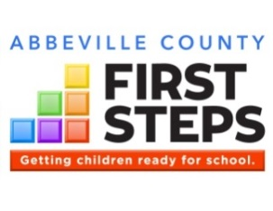
Children involved in high-quality preschool are more likely to have better academic outcomes.

Early Education
Here is the place where you summarize your program. Connect your program’s purpose to the “WHY” statement above.
Describe the desired outcomes of your program.
Describe the components of your program, using subheadings, bullets and/or numbering to organize it for the reader. For example:
- Component 1
- Component 2
- Component 3
If you have risk factor data for this strategy, copy/paste the “risk factor box” from other pages and insert it here.

Program Description
This year, our Early Education program:
- Made it possible for XX children to attend quality preschool (Matrix C57-59)
- Program results such as: child outcomes, parent involvement, nutrition/health, teacher training, etc. if applicable
- Program results such as: child outcomes, parent involvement, nutrition/health, teacher training, etc. if applicable

Use text boxes to caption your photos as often as possible. Many readers will focus on these more than the report text.

Early Education by the Numbers, 2016-17
Children Served | Matrix C57-59
Providers Served | Matrix D57-59

Here’s a great quote from a client!
Client name
Also include any measures of client satisfaction HERE or in the results below

XYZ County First Steps
Address, City, ZIP
Phone
Email Web Address

Thank you to our partners!
XYZ County School District
ABC Child Care
Fairview Mental Health Services

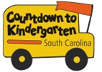

*CTK by the Numbers, Summer 2016
Children Served | Matrix C73
Families Served | Matrix D73
Home/School Visits | Matrix E73

*CTK program data is for June-August 2016, whereas CTK fiscal data includes expenditures from July 1, 2016 through June 30, 2017.
Countdown to Kindergarten (CTK) is a summer home visitation model connecting rising kindergartners and their families with their future teachers. The program is designed:
- to forge strong and lasting home-school relationships,
- to acquaint children and families with the state and classroom expectations to increase the likelihood of school success,
- to increase parent involvement in the early grades (particularly in hard-to-reach communities), when children’s learning is foundational for life success; and
- to increase public awareness of the importance of school readiness and provide ways for parents and communities to impact children’s early school success.

Countdown to Kindergarten integrates all of the following:
Home Visitation. Teachers make six visits over the summer to the homes of participating students and families. Children and families are introduced to actual materials used in kindergarten and are given a Kindergarten Transition Toolkit to keep.
Learning Celebration. The last visit is a “field trip” to the school where the child will attend class in the fall.
Public Awareness. Throughout the summer, First Steps releases tips to media to help parents and caregivers get children ready for kindergarten.

Unless you have a good reason, your CTK results and data should be from Summer 2016 – the same as reported in the data matrix - and survey data from the 2016-17 school year.
However, if you just started CTK in Summer 2017, or made some significant change like increasing the numbers served in Summer 2017, you can report on Summer 2017 instead of, or in addition to, Summer 2016 on this page. Make sure you clearly label your data!
Delete this text box.

Here’s a great quote from a CTK client!
Client name

Countdown to Kindergarten
Bringing parents and teachers together as partners sets the foundation for success in school.
Like us on Facebook!
Countdown to Kindergarten-South Carolina

This year, our Countdown to Kindergarten program:
- Include satisfaction results from parent surveys.
- Increased the amount of time parents spent reading to children by XX%
- According to kindergarten teachers, XX% of CTK children performed as well as, or better than, their fellow students in LIST AREAS FROM THE CTK TEACHER SURVEY during the 2016-17 school year.
- According to kindergarten teachers, XX% of CTK parents were more involved than other parents in their child’s education in the areas of LIST AREAS FROM THE CTK TEACHER SURVEY.

Program Description
The risk factor box underneath is a Table. To add or delete lines, you must Insert or Delete Rows by right-clicking on the appropriate line. This applies to all pages that include a risk factor box.
Use data from the Risk Factor Report to find the most compelling statistics for your program.
Delete this text box.

XYZ County First Steps
Address, City, ZIP
Phone
Email Web Address
XYZ County School District
Kaplan Early Learning Company
EdVenture Children’s Museum
WACH Fox 57

Thank you to our partners!
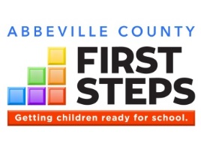

Financial Impact
Change the county name. Delete this text box.

Right click on this pie chart and select “Edit Data” from the toolbar above, or right-click on the pie chart and select “Edit Data”. Enter numbers from the Ethority reports provided. Delete this text box.

Total 2016-17 Expenditures: $305,000
State Funds Leveraged in 2016-17*: 53%
*Percentage of state dollars matched by additional federal, private, and/or in-kind funds

Unaudited numbers for the period July 1, 2016 through June 30, 2017
Double click on this chart to open the Excel spreadsheet and enter numbers from the Ethority reports provided. Delete this text box.
Since inception, XYZ County First Steps has leveraged $X,XXX,XXX from sources outside of state government. That’s XX cents for every state dollar.

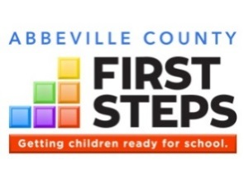
Through partnerships and collaborations, as well as financial support from grants and contributions, XYZ First Steps leverages state dollars to enhance and expand services to children and families.

In-Kind Support
XYZ County School District
ABC Child Care
Fairview Mental Health Services

Funding Support
State of South Carolina: $200,000
(through South Carolina First Steps)
U.S. Department of Education: $50,000
XYZ County Council: $5,000
Dollar General Literacy Foundation: $10,000
Wal-Mart Store #1001, XYZ: $10,000

Support XYZ First Steps today through a tax-deductible donation, or volunteer!

Thank you supporters!
How your support helps children in XYZ County:
- $25 provides a young child a book per month for one year!
- $XXX feeds dinner to low-income families attending a parenting workshop
- $XXX helps a low-income family afford quality child care for one month
- $XXX etc. etc.
HOW TO GIVE: include here instructions on how to submit contributions to your partnership

You can insert a photo of donated items or donors if you like. Delete this text box.
Use text boxes to caption your photos as often as possible. Many readers will focus on these more than the report text.

You can provide info here to donors about how much money it costs to provide a specific service/resource for how many children. Delete this text box.
Use this text box to advertise any community events you have planned for the year, such as your annual meeting, and especially any fundraisers.
If your partnership is going to participate in any giving program like Midlands Gives, add that info here.

Save the Date!
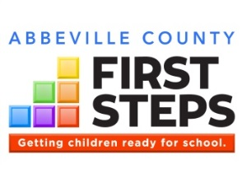
Make a Title for your Success Story
Subtitle/Name of Strategy or Partner

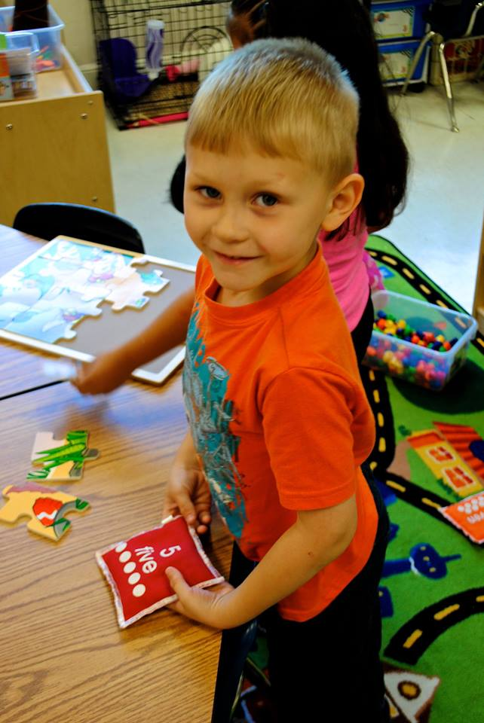
Here is where you write a success story. It can be about whatever you want: a child or family, program, training series, child care center, board member, collaboration, serving as a local portal, whatever. If you have a photo or image you can insert it in place of the photo or you can delete the image.

Community Impact
This is a subheading if you want to use one
Here is where you write a success story. It can be about whatever you want: a child or family, program, training series, child care center, board member, collaboration, serving as a local portal whatever. If you have a photo or image you can insert it in place of the photo or you can delete the image.
Use text boxes to caption your photos as often as possible. Many readers will focus on these more than the report text.
Make a Title for your Success Story
Subtitle/Name of Strategy or Partner
Here is where you write a success story. It can be about whatever you want: a child or family, program, training series, child care center, board member, collaboration, serving as a local portal, whatever. If you have a photo or image you can insert it in place of the photo or you can delete the image.
This is a subheading if you want to use one
Here is where you write a success story. It can be about whatever you want: a child or family, program, training series, child care center, board member, collaboration, serving as a local portal, whatever. If you have a photo or image you can insert it in place of the photo or you can delete the image.
Support XYZ First Steps today through a tax-deductible donation, or volunteer.
Use text boxes to caption your photos as often as possible. Many readers will focus on these more than the report text.
Make a Title for your Success Story about your Board or being a Community Convener
Subtitle/Name of Strategy or Partner

First Steps Partnership Board
Here is where you write a success story about your board or a collaboration involving your board. Here is where you write a success story about your board or a collaboration involving your board. Here is where you write a success story about your board or a collaboration involving your board. Here is where you write a success story about your board or a collaboration involving your board. Here is where you write a success story about your board or a collaboration involving your board. Here is where you write a success story about your board or a collaboration involving your board.
This is a subheading if you want to use one
Here is where you write a success story about your board or a collaboration involving your board. Here is where you write a success story about your board or a collaboration involving your board. Here is where you write a success story about your board or a collaboration involving your board.
Name | Position | Board Category
Betty Gardiner, Chair | Early Childhood Coordinator, Lexington/Richland 5 | School District Representative
Debbie Robertson, Vice Chair | Director of Child Care Services, Lexington County DSS | DSS Representative
Mary Anne Mathews | President, ABC Company | Parent of a Young Child

XYZ County First Steps Partnership Board, 2016-17

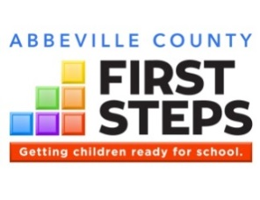

Getting children ready for school.

The Goals of First Steps

(1) provide parents with access to the support they might seek and want to strengthen their families and to promote the optimal development of their preschool children;
(2)increase comprehensive services so children have reduced risk for major physical, developmental, and learning problems;
(3)promote high-quality preschool programs that provide a healthy environment that will promote normal growth and development;
(4)provide services so all children receive the protection, nutrition, and health care needed to thrive in the early years of life so they arrive at school ready to succeed; and
(5)mobilize communities to focus efforts on providing enhanced services to support families and their young children so as to enable every child to reach school healthy and ready to succeed.
-- Section 59-152-30

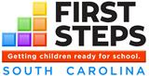
EARLY HEAD START – CHILD CARE PARTNERSHIP
Low income families with children 0-36 months, and families with infants or toddlers with special needs, are invited to apply for this year-round, comprehensive program. Available in the following counties: Allendale, Anderson, Bamberg, Berkeley, Dillon, Georgetown, Laurens, Lexington, Newberry, Orangeburg, Saluda and York, and coming coon to Fairfield and McCormick counties. To apply, visit:
http://scfirststeps.org/ehs/
Interested parents with Medicaid-eligible children who live in eligible school districts can contact any participating provider to complete an application for free, full-day 4K. To view a list of participating First Steps 4K providers, visit:
http://scfirststeps.org/4k

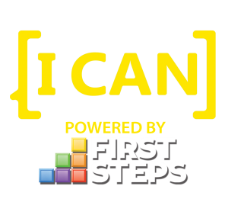
[I CAN] is First Steps’ public awareness campaign for school readiness, in support of the state’s Profile of the Ready Kindergartener. Includes resources for parents, providers and communities to learn what they can do to support school readiness.
Visit: ican.sc
Like us on Facebook: icansc

