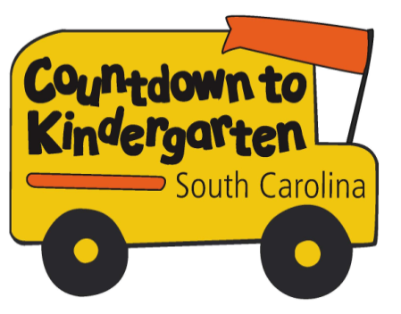 | Weekly Activities –  Visit One

- Read a book with your child every day. Look for opportunities to pause and ask your child “open- ended” questions about the story. (Open-ended questions have many possible answers. For example: “What do you think will happen next?” or “Can you think of a time you felt scared like (the character in the book)?”

- Use Crayons to draw a picture of your family. Sit together and label each family member by name. Talk about the letters needed to write the name of each.

- Visit your local library with your child. If you don’t have a library card you can sign up for one – they’re free!

- Review the parent handout Television and Your Kindergartner.

- Develop a list of your questions about kindergarten and the coming school year
for discussion during a future visit. This list may include both your own parent questions and those of your child.

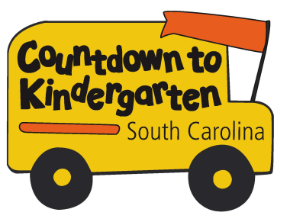 | Countdown to Kindergarten  Family Commitment Form
Countdown to Kindergarten is a First Steps to School Readiness program to help children get ready for school. As your family’s Countdown teacher, I will meet with you and your child five times to teach and engage in activities that will help prepare your child for kindergarten. On the last visit, we will meet at school so you and your child can see the child’s new kindergarten classroom. There will be art materials, educational toys, and/or a book provided for each visit/lessons. The lessons for each visit and the date and time we will meet are:

Week 1-Getting to Know You
Date/Time of Visit 1: _______________________________________________________________

Week 2 – English Language Arts and Literacy
Date/Time of Visit 2: _______________________________________________________________

Week 3 - Math
Date/Time of Visit 3: _______________________________________________________________

Week 4 - Science
Date/Time of Visit 4: _______________________________________________________________

Week 5 - Social Studies
Date/Time of Visit 5: _______________________________________________________________

Week 6 - Visit to the School and Student’s Classroom
Date/Time of Visit 6: _______________________________________________________________

By signing this form, I agree that my child and I will participate in all six visits that I schedule with the Countdown to Kindergarten teacher. If I am unable to keep a scheduled visit, I will contact the teacher and reschedule for another time. I agree to be present at the five home visits and to attend the final visit at my child’s classroom.

______________________________________________ __________________________
Parent/Guardian Name Date

__________________________________________________ ____________________________
Teacher Name Date

_________________________________________________
Teacher Contact Information

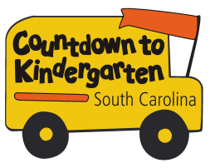 | Television and Your Kindergartener

Television has a huge influence on our children. The average American spends about 4 hours per day watching television. The American Academy of Pediatrics does not recommend television for children younger than 2 years. After this age, parents may wish to allow their child to watch TV for short periods of time. According to most sources, about one hour of TV per day is enough. Make sure that you balance TV time with more active, interpersonal activities like reading, dancing, and singing with your child.

Too much TV can lead to:
Obesity Poor grades Lack of imaginative play
Inferior reading skills Poor social skills

Children who watch violent shows may:
Become desensitized to violence
Imitate the violence they see
Identify with the victimizers or the victims
Be more fearful of their own world
View violence as the way to solve problems

To help you establish healthy TV habits in your home, here are some suggestions from the National Association for the Education of Young Children:
- Plan your family viewing. Give your child a choice of what to watch – within your guidelines. Set and keep reasonable limits.
- Move the TV to a room that is not at the center of family life. The American Academy of Pediatrics recommends parents not allow a TV in their child’s room.
- Offer your child fun and constructive activities like reading, outside play, and drawing. These activities will help your child’s development in all areas and can distract her from wanting to watch too much TV.
- Watch TV with your child and talk about the program you view together. Explain, comment, and give your opinions about what your see.
- Discuss commercials with your child. Young children tend to believe what they see on TV and have not yet developed the ability to evaluate these manipulative messages. Point out when advertisers make false or exaggerated claims. Help your child develop critical thinking skills by your example.

Remember: You can use the TV as a tool for entertainment and education without allowing it to control your home life. Set limits on your child’s viewing time and choose appropriate shows so that television enriches, but does not rule, your kindergartener’s development.

Adapted from Parents as Teachers National Center, Inc., 1997

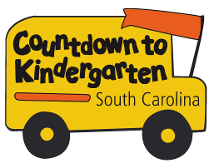 | Weekly Activities – Visit Two

- Continue to read with your child daily. Some recommended alphabet books are:
ABC’s by Eric Carle
Alphabet Adventure by Audrey Wood
Dr. Seuss’s ABC
Alphabet Under Construction by Denise Fleming

- Use the magnetic letters to create additional words (the name of each family member and/or that of a family pet, for example) and to practice letter recognition. See how many letters your child can name independently.

- Review the Parent Handouts titled The Importance of Play and Language Strategies for Parents.

- Familiarize yourself with the SC Kindergarten Learning Standards for English Language Arts and Literacy, noting any questions you may have for your teacher. Remember that these are year-end expectations that will be developed in the context of daily classroom activities across a full year.
While it is possible that your child may be advancing toward (or have successfully attained) mastery of some standards already, do not be alarmed if this is not the case. Parents are not encouraged to turn the standards into a high-pressure drill. Instead, consider the many ways in which you can support and encourage their mastery within the context of daily conversation and activity.

- Use the magnetic letters to practice making some of the sight words in the writing journal. Also practicing writing these words in the journal

- If you have access to the internet, explore some reading websites. Some suggested ones are:
www.ABCYA.com
www.Starfall.com
www.PBSkids.com
www.storylineonline.com
www.seussville.com

The Importance of Play

What is Play?
Play is an important means by which the child develops and learns. Play is a young child’s work, but is also a way of learning about things, people and places. A child’s play needs to be meaningful, pleasant, and varied. From the earliest form of social games such as smiling at an adult to the more sophisticated dramatic play of the five year-old, play takes on many forms and meanings. Play gives the child a sense of power over reality. Play lets the child take on adult roles and adult language. Play builds muscles and makes them work together. Play coordinates the eye and hand. Most of all, play extends the self and helps the child develop a creative mind and a positive self-image. For young children, there is no distinction between “play” and “work”, there is only doing – experiencing and learning. And they are intrinsically motivated to discover things about their world by interacting with people, things and ideas. When parents understand this, they will support their children’s discoveries and help them take advantage of the multitude of learning experiences that occur throughout the day.
Play is the best way for our children to learn. Children who learn through play also develop social and emotional skills, which are critical for long-term success. Children need time to just be – they need time for unstructured play.

Value of Play
Some parents may express concern about the amount of time children are allowed to play. If you encounter this, you may want to remind them how much their child has already learned without any direct teaching. For example, say something like this: “Just look at all the things Lindsey learned during her first four years, long before she ever set foot in any classroom.” Point out that Lindsey learned to walk, talk, sing, move to music, put most of her clothes on, use the toilet, feed herself, recognize friends and relatives, interact with other people, and so forth, all before she entered school.

Play:
- is the child’s teacher. Play is the way young children learn to solve problems. Play is the work of children.
- allows children to express feelings, use their creativity, and expand their imaginations.
- develops small and large muscles.
- motivates the child’s intellectual learning.
- allows the child opportunities to make choices and learn new skills.

Language Strategies
for Parents

- Verbally describe your actions.
  - “I’m going to put all the white clothes in this pile, and the dark clothes in this pile.”
  - “I’m writing a letter to Grandma.”

- Describe your child’s actions.
  - “I see that you are putting all the blocks on the top shelf.”
  - “You are putting on your blue socks today.”

- Ask your child to describe something he did.
  - “Tell me about your drawing.”
  - “Tell me how you made this book.”

- After your child has told you something, restate and expand on what she said.
  - “Oh, you’re going to play with Brad at school tomorrow?”
  - “Yes, you really do need a band aid on your knee.”

- Ask questions requiring thinking and more than one-word responses.
  - “What could happen if we put another block on the tall tower?”
  - “What do we need to take on our picnic?”

- At the grocery store, on a walk, etc., talk about things you see.
  - “I wonder how that man got up on the roof.”
  - “Look at that family who has two babies in the shopping cart!”

- Have a conversation with your child. Each person should have two or three turns to say something about the same topic.
  - Mother: “What did you see at the zoo today?”
  - Child: “I saw some bears.”
  - Mother: “Oh! Tell me what they looked like.”
  - Child: “They were big and furry.”
  - Mother: “What were the bears doing?”
  - Child: “Sleeping and playing on the rocks.”

English Language Arts and Literacy Standards for Kindergarten

Learning new language skills is a hallmark of kindergarten. Your child will learn about the alphabet and its role in reading. Your child will practice rhyming, matching words with beginning sounds, and blending sounds into words. Practice with these types of activities is a powerful step toward learning to read and spell correctly. The size of your child’s vocabulary is another key factor in his or her ability to read and comprehend books and stories. Your child also will begin to experiment with writing and will be encouraged to use a combination of drawing, dictating, and writing letters to share information, ideas, and feelings.

The following is a sample of English Language Arts and Literacy Standards that your child will be working on:
- Naming upper- and lower-case letters, matching those letters with their sounds, and printing them
- Comparing the adventures and experiences of characters in familiar stories, such as fairy tales and folktales
- Retelling familiar stories and talking about stories read to them using details from the text
- Using a combination of drawing, dictating, and writing to describe an event, including his or her reaction to what happened
- Stating an opinion or preference about a topic or book in writing (e.g., “My favorite book is . . .”)
- Taking part in classroom conversations and following rules for discussions (e.g., learning to listen to others and taking turns when speaking)
- Speaking clearly to express thoughts, feelings, and ideas, including descriptions of familiar people, places, things, and events
- Asking and answering questions about key details in stories or other information read aloud
- Understanding and using question words (e.g. who, what, where, when, why, how) in discussions
- Learning to recognize, spell, and properly use those little grammatical words that hold the language together (e.g., a, the, to, of, from, I, is, are)

Here are some things you can do with your child to promote English Language Arts and Literacy at home:

- Read with your child every day. (Some suggested books: Are You My Mother by P.D. Eastman or Green Eggs and Ham by Dr. Seuss.) Ask your child to explain his or her favorite parts of the story. Share your own ideas. To find more books for your child to read, visit www.corestandards.org/assets/Appendix_B.pdf.
- Encourage your child to tell you about his or her day at school. Keep paper, markers, or crayons around the house for your child to write letters or words or draw a picture about his or her day. Have your child describe the picture to you.
- Play word games like I Spy, sing songs like Itsy Bitsy Spider, and make silly rhymes together.

Adapted from the National PTA

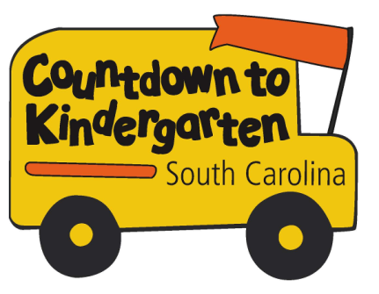 | Weekly Activities –  Visit Three

- Continue to read with your child daily.

- Use the Unifix cubes (or other materials) to create additional patterns and to practice counting objects. As your child counts, encourage him/her to use a finger to touch each object (as necessary) to reinforce the idea that for each number we name there must also be a matching object. Keep a watchful eye to ensure that each object is counted once, but only once.

- Assemble the number puzzle together, asking your child to join you in naming each number aloud.

- Review and try some of the activities included in the Parent Handouts titled: Number Sense and Patterning Games.

5. Familiarize yourself with the SC Kindergarten Learning Standards for Math, noting any questions you may have for your teacher. As you read, give thought to daily occurrences during which you may be able to incorporate their practice and development – recognizing as always that these are year-end expectations.

Math Standards for Kindergarten

Young children arrive in kindergarten with widely varying knowledge in math. By the end of the year, your child must have some important foundations in place. One of the most important skills your child should develop is the ability to add and subtract small numbers and use addition and subtraction to solve word problems. This will rely on gaining some fundamentals early in the year, such as counting objects to tell how many there are. Addition and subtraction will continue to be a very strong focus in math through 2nd grade.

The following is a sample of Math Learning Standards that your child will be working on:

- Counting objects to tell how many there are
- Comparing two groups of objects to tell which group, if either, has more; comparing two written numbers to tell which is greater
- Acting out addition and subtraction word problems and drawing diagrams to represent them
- Adding with a sum of 10 or less; subtracting from a number of 10 or less; and solving addition and subtraction word problems
- Adding and subtracting very small numbers quickly and accurately (e.g., 3 + 1)
- Correctly naming shapes regardless of orientation or size (e.g., a square oriented as a “diamond” is still a square)

Here are some things you can do with your child to promote Math at home:

Look for “word problems” in real life. Some kindergarten examples might include:
- Play “Write the next number.” You write a number, and your child writes the next number.
- Ask your child questions that require counting as many as 20 things. For example, ask, “How many books do you have about wild animals?”
- Ask your child questions that require comparing numbers. “Who is wearing more bracelets, you or your sister?” (Your child might use matching or counting to find the answer.)

Adapted from the National PTA

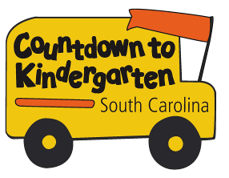 | Number Sense

Many young children count aloud (from memory) without fully understanding that each spoken number represents a matching quantity. Developing this “number sense” is an important foundation upon which all future mathematics is based.

Developmentally, preschoolers make many common errors as they form these number concepts. At first, they rely on appearances as they compare amounts. For example, they may say three big cars are more than four smaller cars. Or they may insist a cookie broken into two pieces is now more than a whole cookie. When counting, they may skip objects or count the same object twice. As they use number concepts for their own purposes, children will gradually make fewer errors.

Same ways to help:
- Don’t overemphasize “rote” or memorized counting (counting aloud to 20 or 50, for example) at the expense of developing a strong “number sense.” At this point, the ability to connect the word “seven” (or even “twenty”) to a set of seven (or twenty) corresponding objects, for example, is of far greater conceptual value.

- Allow your child to learn by doing. Give him chances to divide objects into groups. This could be dividing blocks to share with a friend or dividing a package of cookies to share with a brother/sister. Ask him/her to set the table – counting out just enough plates, forks, cups and napkins so that everyone coming to dinner will have one of each.

- Encourage your child to compare the number of items in two sets by matching them up one-to-one. (“Which number is bigger - seven or nine? Let’s count out two sets of cubes and find out.”)

- Visit the library. Some suggested “number sense” books include:

Feast for 10 by C. Falwell
Five Little Ducks by P. Paparone
Gray Rabbit’s 1, 2, 3 by A. Baker
Number One, Number Fun by K. Charao
One Gorilla by A. Morozumi
One Cow Moo Moo! by D. Bennett & A. Cooke
Five Little Monkeys Jumping on the Bed by E. Christelow
Five Little Monkeys Sitting in a Tree by E. Christelow

- Explore the internet for math websites. Two suggested ones are:
www.ABCYA.com
www.coolmath.com

Patterning Games

Patterns are all around us. Here are some things you can do to help your child recognize and create his or her own patterns.

- Go on a “pattern hunt” with your child. Look for patterns (in fabric, wallpaper, plates, etc.).

- Make different patterns using common household objects (forks and spoons, Legos, paperclips, etc.) Encourage your child to make her own pattern using socks and then try to guess the pattern.

- Go to the library with your child and look for some of the books emphasizing patterns. Suggested titles include:

The Bag I Am Taking to Grandma’s by S. Neitzel
The Grouchy Ladybug by E. Carle
The House That Jack Built by C. and J. Hawkins
I Know an Old Lady by B. Karas
Lots and Lots of Zebra Stripes: Patterns in Nature by S. Swinburne
The “M&M’s” Brand Color Pattern Book by B. McGrath
The Napping House by A. Wood
Nature’s Paintbrush: The Patterns and Colors Around You by S. Stockdale
Pattern (Math Counts) by H. Pluckrose
Pattern Bugs by T. Harris and A. Green
Pattern Fish by T. Harris and A. Green
Patterns by C. Hammersmith
Patterns (Math Links) by P. Patilla
The Quilt Story by T. Johnston and T. DePaola
Spotted Yellow Frogs by M. Van Fleet
The Three Bears by P. Galdone
Twizzlers: Shapes and Patterns by J. Pallotta
Zoe’s Hats: A Book of Colors and Patterns by S. Holm

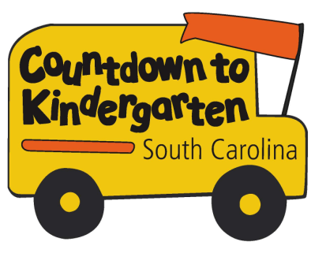 | Weekly Activities –  Visit Four

- Continue to read with your child daily.

- Use your magnifying glass to continue exploring your home and outdoor surroundings.

- Have a follow up discussion with your child about how scientists are people who want to learn more about something that interests them. Ask your child to consider what he might like to study if he/her was to become a scientist. Visit the local public library or do an online search with your child to learn more about a topic that he or she would like to learn more about.

- Review the Parent Handout titled: The Importance of Sleep.

5. Familiarize yourself with the SC Kindergarten Learning Standards for Science, noting any questions you may have for your teacher. As you read, give thought to daily occurrences during which you may be able to incorporate their practice and development – recognizing as always that these are year-end expectations.

Science Learning Standards for Kindergarten
Students should be able to:
Inquiry and Process Skills
- Identify observed objects or events by using the senses
- Use tools (including magnifiers and eyedroppers) safely, accurately, and appropriately
- Predict and explain information or events based on observation or previous experience
- Compare objects by using nonstandard units of measurement
- Use appropriate safety procedures when conducting investigations

Characteristics of Organisms
- Recognize what organisms need to stay alive (including air, water, food, and shelter)
- Identify examples of organisms and nonliving things
- Match parents with their offspring to show that plants and animals closely resemble their parents
- Compare individual examples of a particular type of plant or animal to determine that there are differences among individuals
- Recognize that all organisms go through stages of growth and change called life cycles

My Body
- Identify the distinct structures in the human body that are for walking, holding, touching, seeing, smelling, hearing, talking, and tasting
- Identify the functions of the sensory organs (including the eyes, nose, ears, tongue, and skin)

Seasonal Changes
- Identify weather changes that occur from day-to-day
- Compare the weather patterns that occur from season to season
- Summarize ways that the seasons affect plants and animals

Exploring Matter
- Classify objects by observable properties (including size, shape, magnetic attraction, heaviness, texture, and the ability to float in water)
- Compare the properties of different types of materials (including wood, plastic, metal, cloth, and paper) from which objects are made

Activities Have your child:
- Cut pieces of fabric, cork, paper and other such items into similar shapes. With eyes closed, try to identify the different materials based on touch
- Collect leaves and sort them by size, shape, color, and texture. Have your child invent a way to measure the size using an object other than a ruler such as his hand.
- Go to a zoo and ask your child to predict what animals in the same section of the zoo have in common
- Track the weather for several days in a row and ask your child to try to predict the next day’s weather. Ask him/her to tell you why he/she predicted what would happen.
- Discover what objects will stick to a kitchen magnet
- Identify an object by the type of material from which it is made (wood, plastic, metal, cloth, or paper)
Books: Websites:
Aliki - My Five Senses AAAS Science Netlinks – www.sciencenetlinks.com
Aliki - My Visit to the Zoo National Wildlife Federation – www.nwf.org/kids
Fowler, Allan - What Magnets Can Do
Gibbons, Gail - Seasons of Arnold’s Apple Tree
Hall, Zoe - The Surprise Garden
Hickman, Pamela - A Seed Grows
Kingfisher Publishing - Animal Babies on the Farm

The Importance of Sleep

How Much Sleep Does My Child Need?
At age 5, some children still need a daytime nap to recharge their batteries, but most have learned to pace themselves throughout the day and sleep longer at night. As at every stage of childhood, it’s best to keep to a routine without being rigid. In other words, if your child is tired or irritable during the day or wants to nap, let him do so. By the time they enter kindergarten most children need 10 to 12 hours of sleep daily.

After a day of non-stop activities at school, the average 5-year-old is tired. Even if she resists the idea of going to sleep, it’s a good idea to get her ready by giving her a bath and changing her into sleepwear for a quiet time—playing a board game, reading a story, or just talking over the events of the day—so that when the eyelids droop, it’s only a step into the bed.

The Problem with Not Getting Enough Sleep
Children who chronically fail to get enough sleep do not learn as well as better-rested youngsters. They also have a higher rate of behavior problems. In many cases, overtired children resort to hyperactivity and difficult behavior as a way of fighting off daytime drowsiness.

Is My Child Getting Enough Sleep?
If you answer “yes” to any of these questions, it may be time to bring the problem to your pediatrician’s attention:
- Is my child difficult to wake up most mornings?
- Is my child lacking in energy?
- Does my child refuse meals because he’s too tired to eat?
- Does my child have difficulty settling to sleep because she is over stimulated?
- Is my child often irritable or cranky at about the same time of the day?
- Are our family’s nights disturbed because of our child’s nighttime waking?

Additional Resources
American Academy of Pediatrics Guide to Your Child’s Sleep, George J. Cohen, M.D., Editor
Sleepless in America – Is Your Child Misbehaving or Missing Sleep? Mary Sheedy Kurcinka

- Reprinted with permission of author Sarah Conrad

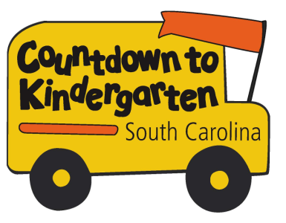 | Weekly Activities –  Visit Five

- Continue to read with your child daily.

- Spend some time writing with your child in the journal each day. Remember that writing is a developmental process in which your child will gradually progress from using scribble-like marks and/or simple pictures to increasingly conventional or “correct” forms. Honor what your child can do now – never dismissing it as less than “real writing” – while providing many opportunities to help him/her communicate through print. You’ll be amazed at the progress you’ll see in this area over the next twelve months!

- Review the Parent Handouts titled: Developmental Stages of Writing and Ways Parents Can Encourage Writing.

5. Familiarize yourself with the SC Kindergarten Learning Standards for Social Studies, noting any questions you may have for your teacher. As you read, give thought to daily occurrences during which you may be able to incorporate their practice and development – recognizing as always that these are year-end expectations.

 | Developmental Stages of Writing
Scribble Stage  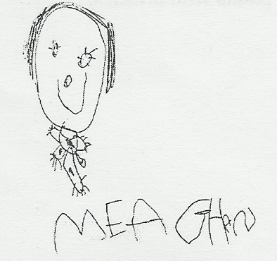  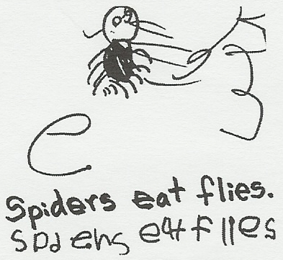  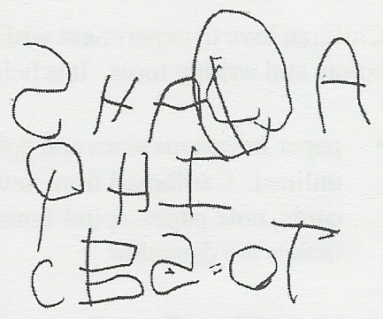  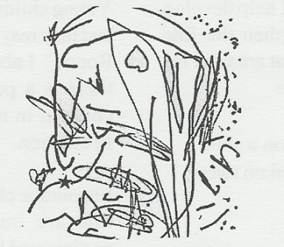  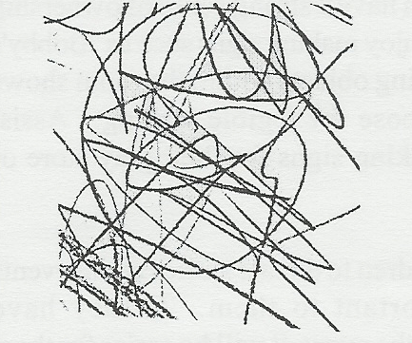  Scribbles are lines and circles starting any place on the page. |  | Separated Scribbles  Scribbles separate as child moves pencil to many starting points. | Left to Right Scribbles  Child moves pencil across the page from left to right.
Scribble/Mock Writing  Scribbles resemble writing with no identifiable letters. |  | First Letters  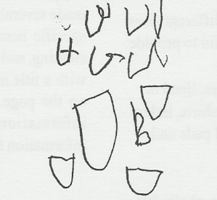  Some scribbles resemble actual letters. | Transition Stage  First attempts to make specific letters.
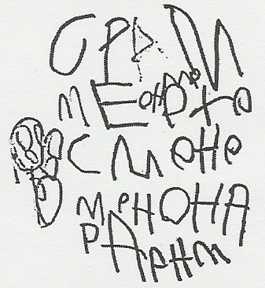  Strings of Letters  Child writes letters without forming words. |  | Copies Print  Child interested in writing real words and attempts copying. | Conventional Writing  Child writes real words and is interested in spelling.

Parents as Teachers National Center, Inc., 1997

Social Studies Standards for Kindergarten

Foundations of Social Studies: Children as Citizens

Students should be able to:
Identify the location of his or her home, school, neighborhood, and city or town on a map
Illustrate the features of his or her home, school, and neighborhood by creating maps, models and drawings
Identify his or her personal connections to places, including home, school, neighborhood, and city and or town
Recognize natural features of his or her environment, e.g., mountains and bodies of water
Explain the purpose of rules and laws and the consequences of breaking them
Summarize the roles of authority figures in a child’s life, including those of parents and teachers
Identify authority figures in the school and community who enforce rules and laws that keep people safe, including crossing guards, bus drivers, fire fighters, and police officers
Explain how following rules and obeying authority figures reflect qualities of good citizenship, including honesty, responsibility, respect, fairness, and patriotism
Recognize the importance of symbols of the United States that represent its democratic values, including the American flag, the bald eagle, the Statue of Liberty, the Pledge of Allegiance, and “The Star-Spangled Banner”
Identify the reasons for celebrating national holidays, including Veterans Day, Thanksgiving, and Martin Luther King, Jr. Day, Presidents ’ Day, Memorial Day, and Independence Day
Describe the actions of important figures that reflect the values of American democracy, including George Washington, Abraham Lincoln, Susan B. Anthony, Rosa Parks, and Martin Luther King, Jr.
Compare the daily lives of children and their families in the past and present
Explain how changes in types of transportation and communication have affected the way families live and work together
Recognize the ways community businesses have provided goods and services for families in the past and do so in the present
Recognize that families of the past have made choices to fulfill their wants and needs and that families do so in the present

Activities Have your child:
- Identify your city on a local map
- Point out geographic features in his/her community, such as lakes or mountains, that make it unique
- Participate in a family game night. Help your child learn to follow the rules of the game, including taking turns. Discuss why following the rules makes the game fun for everyone
- Point out people in the community who should keep him/her safe, such as the school crossing guard, police officer or teacher
- During different activities point out American symbols of democracy such as the United States flag, the bald eagle, patriotic songs, and the Pledge of Allegiance. Discuss the significance of these symbols
- Visit with older members of the family and discuss the ways life was different in the past
- Identify some goods and services provided by local businesses
- Volunteer to pick up litter or do something else that helps the community or school. Talk about how this demonstrates good citizenship
- Read the Pledge of Allegiance to your child and discuss what each part means

Social Studies Books and Websites

Books:
Barnes, Peter and Cheryl - Woodrow, the White House Mouse
Barnes, Peter and Cheryl - House Mouse, Senate Mouse
Barnes, Peter and Cheryl - Marshal, the Courthouse Mouse
Barnes, Peter and Cheryl - Woodrow for President
Brisson, Pat - Benny’s Pennies
Hall, Donald - The Ox Cart Man
Halliman, P.K. - For the Love of the Earth
Hoban, Tana - I Read Symbols
Hoberman, Mary Ann - A House is a House for Me
Hudson, Cheryl W. and Bernette G. Ford - Bright Eyes, Brown Skin
Kennan, Shelia - O Say Can You See? America’s Symbols, Landmarks, and Important Words
Leedy, Loreen - Mapping Penny’s World
Leedy, Loreen - Who’s Who in My Family?
Penner, Lucille Recht - The Statue of Liberty
Parish, Peggy - Amelia Bedelia’s Family Album

Web Sites:

Children’s Books – www.cbcbooks.org
National Geographicwww.nationalgeographic.com
Public Broadcast System (PBS) – www.pbs.org
Primary Games – www.primarygames.com
United States Mint – www.usmint.gov
Weekly Reader – www.weeklyreader.com
History of the American Flag –
www.usflag.org/history/pledgeofallegiance.html
Lessons for Teaching Citizenship –

www.goodcharacter.com/pp/citizenship.html

Ways Parents Can Encourage Writing

Activities and appropriate toys will help develop hand-eye coordination and strengthen the fine muscles in the hands and fingers that are used for writing. A suggested list would be:

- Stringing large, wooden beads on a shoestring; stringing elbow macaroni on twine; putting puzzles together.

- Modeling clay and finger paint are good examples of materials that help develop these muscles.

Children love to experiment with different sizes, colors and writing tools. It is helpful to provide:

- Paper in various sizes and colors, lined or unlined. Cardboard from new shirts, index cards, note paper, spiral-bound pads and tablets.

- Large and small pencils, crayons, chalk, felt-tip and ballpoint pens, non-toxic markers, finger paints, watercolors, and tempera paints with brushes.

Young children have a strong sense of ownership and they may enjoy making signs such as “Bobby’s Room.” Labeling objects within the room shows there is a purpose for legible writing. Assist children in making signs for their play store or fire station.

Encourage children to dictate stories about events that are important to them. If they have participated in the event, it will be easier for them to dictate a story. Also, help your child make a picture book. Allow the child to select any picture that interests him. After the child has made several picture books, suggest the child find specific items – animals, red objects, food, and clothing – and paste the related pictures on the page with a title at the top of the page telling what is on the page. This helps the child to classify information – a prerequisite for organizing information for remembering.

Top Ten Signs of a Good Kindergarten Classroom

Kindergarten is a time for children to expand their love of learning, their general knowledge, their ability to get along with others, and their interest in reaching out to the world. While kindergarten marks an important transition from preschool to the primary grades, it is important that children still get to be children -- getting kindergarteners ready for elementary school does not mean substituting academics for play time, forcing children to master first grade "skills," or relying on standardized tests to assess children's success.
Kindergarten "curriculum" actually includes such events as snack time, recess, and individual and group activities in addition to those activities we think of as traditionally educational. Developmentally appropriate kindergarten classrooms encourage the growth of children's self-esteem, their cultural identities, their independence and their individual strengths. Kindergarten children will continue to develop control of their own behavior through the guidance and support of warm, caring adults. At this stage, children are already eager to learn and possess an innate curiosity. Teachers with a strong background in early childhood education and child development can best provide for children what they need to grow physically, emotionally, and intellectually. Here are 10 signs of a good kindergarten classroom:
- Children are playing and working with materials or other children. They are not aimlessly wandering or forced to sit quietly for long periods of time.
- Children have access to various activities throughout the day, such as block building, pretend play, picture books, paints and other art materials, and table toys such as legos, pegboards, and puzzles. Children are not all doing the same things at the same time.
- Teachers work with individual children, small groups, and the whole group at different times during the day. They do not spend time only with the entire group.
- The classroom is decorated with children’s original artwork, their own writing with invented spelling, and dictated stories.
- Children learn numbers and the alphabet in the context of their everyday experiences. Exploring the natural world of plants and animals, cooking, taking attendance, and serving snack are all meaningful activities to children.
- Children work on projects and have long periods of time (at least one hour) to play and explore. Filling out worksheets should not be their primary activity.
- Children have an opportunity to play outside every day that weather permits. This play is never sacrificed for more instructional time.
- Teachers read books to children throughout the day, not just at group story time.
- Curriculum is adapted for those who are ahead as well as those who need additional help. Because children differ in experiences and background, they do not learn the same things at the same time in the same way.
- Children and their parents look forward to school. Parents feel safe sending their child to kindergarten. Children are happy; they are not crying or regularly sick.
Individual kindergarten classrooms will vary, and curriculum will vary according to the interests and backgrounds of the children. But all developmentally appropriate kindergarten classrooms will have one thing in common: the focus will be on the development of the child as a whole.
Copyright 2008 by the National Association for the Education of Young Children.

